Set up a react app in VS Code by running the command.

ChatGPT Hackathon

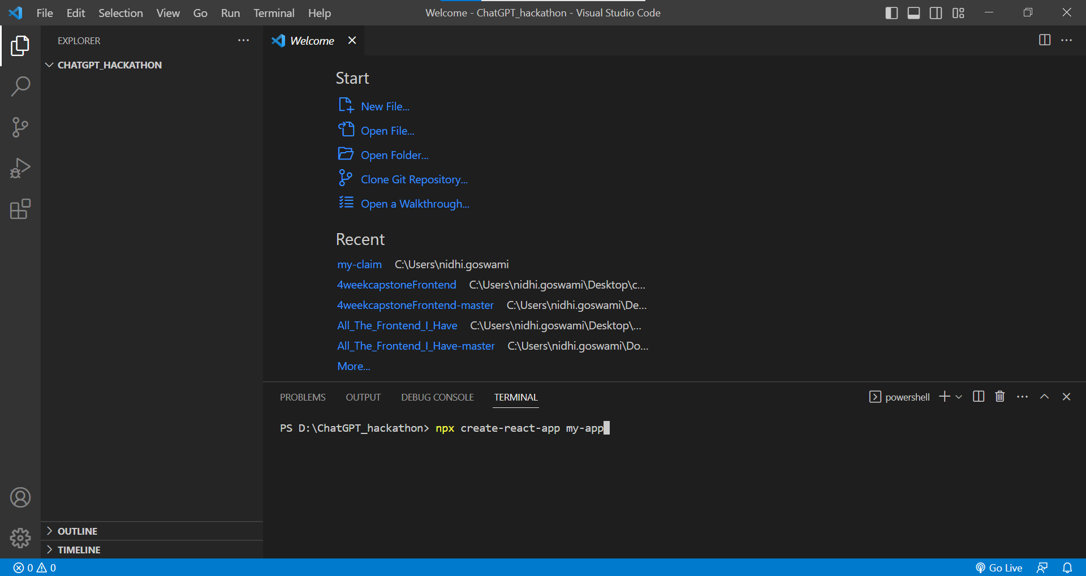

Our new react app is created in VS Code.

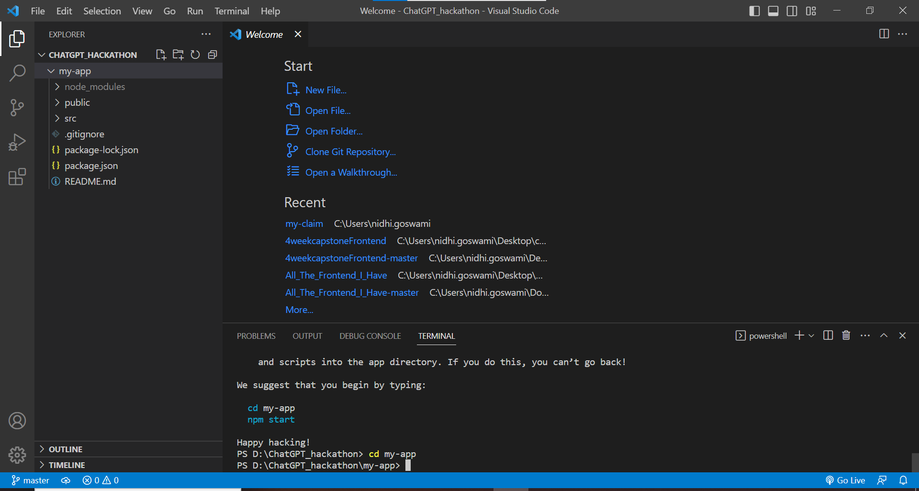

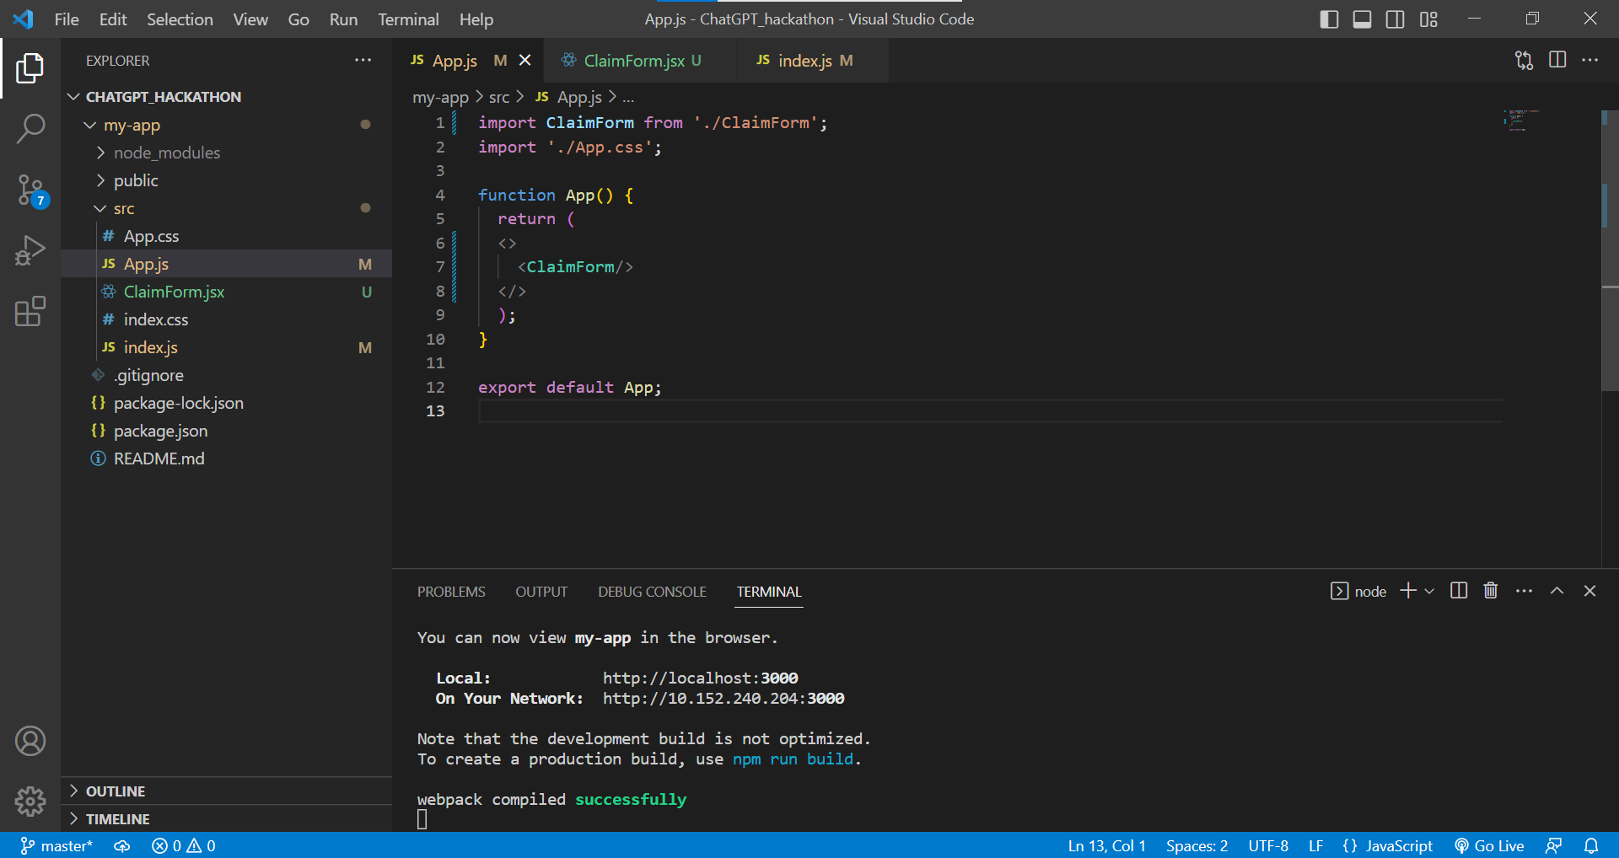

Installing the extension of ChatGpt which is ChatGpt- Genie AI.

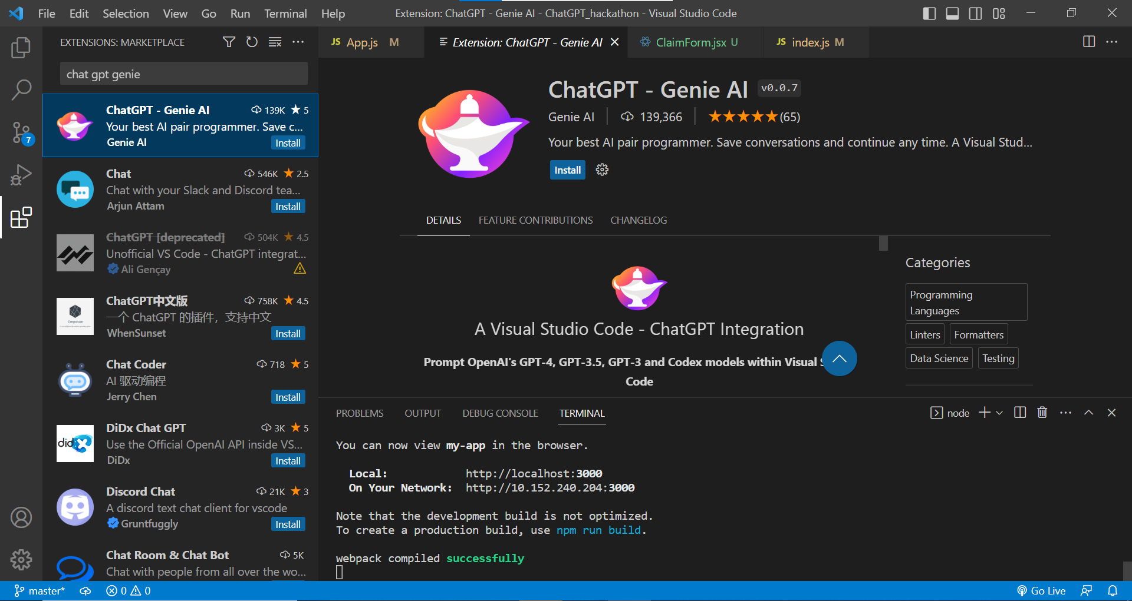

When we try to work with it, it asks for the OpenAI API Key.

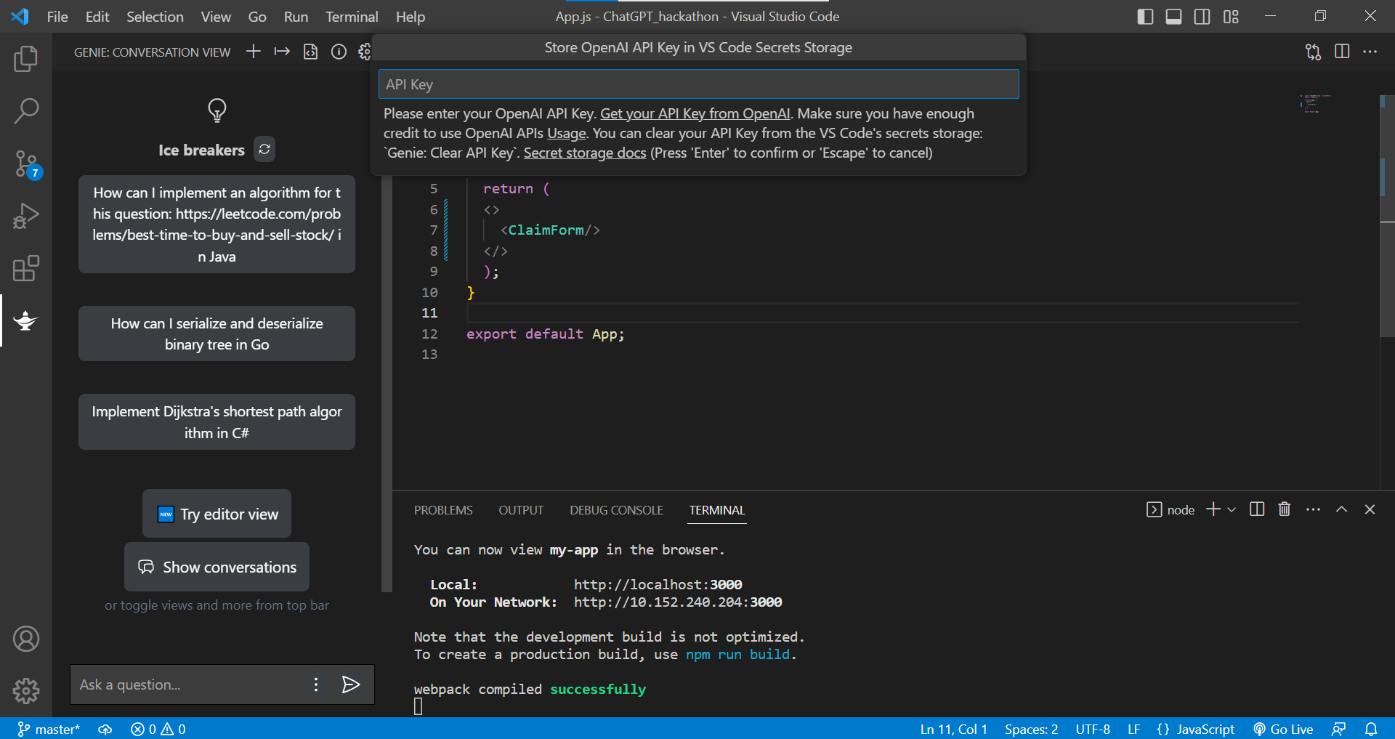

So, to get the API key, Open ChatGpt go to API Keys, then click on create new secret key. This will generate an API key for you.

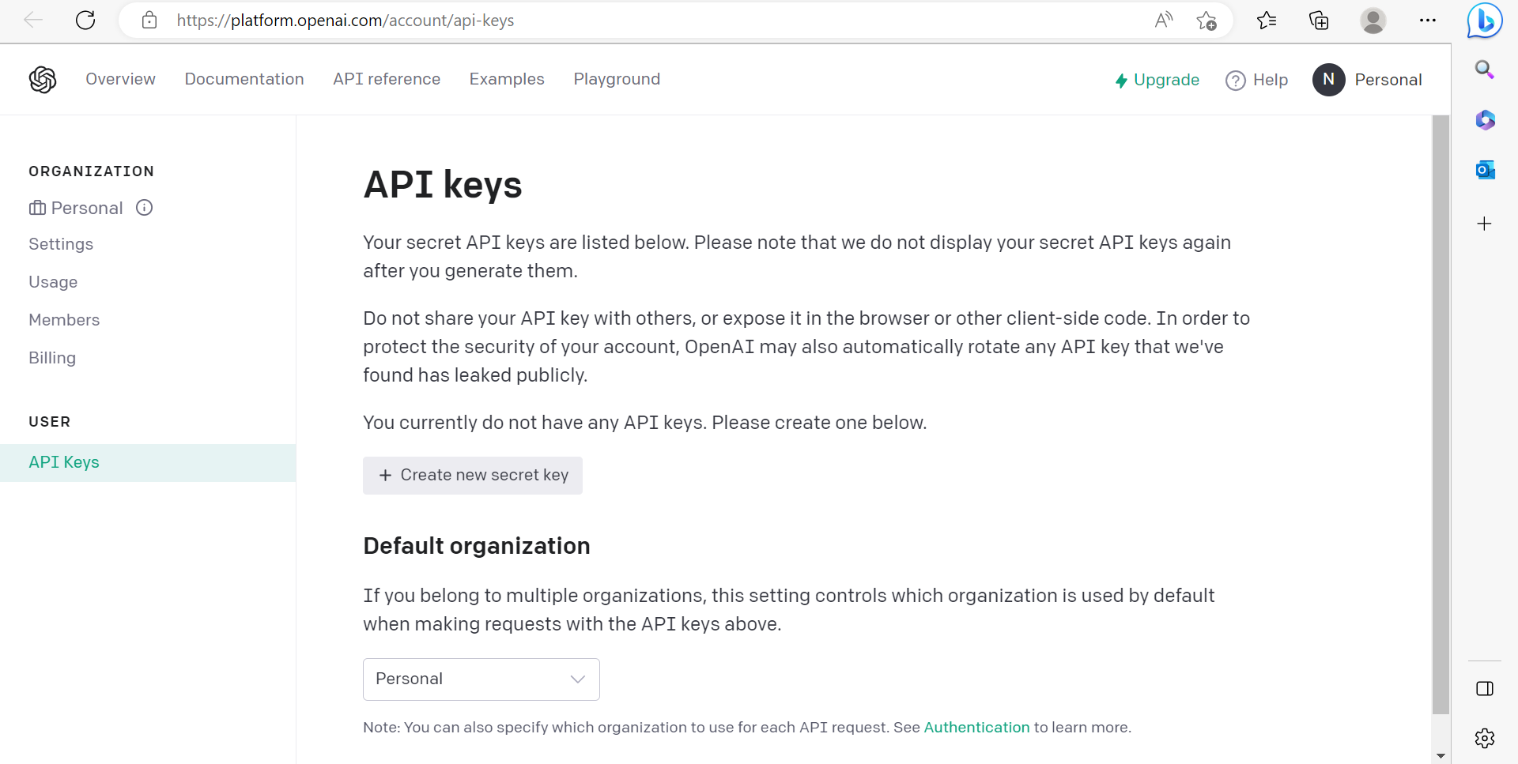

Entering this API key here will integrate our VS Code with ChatGPT.

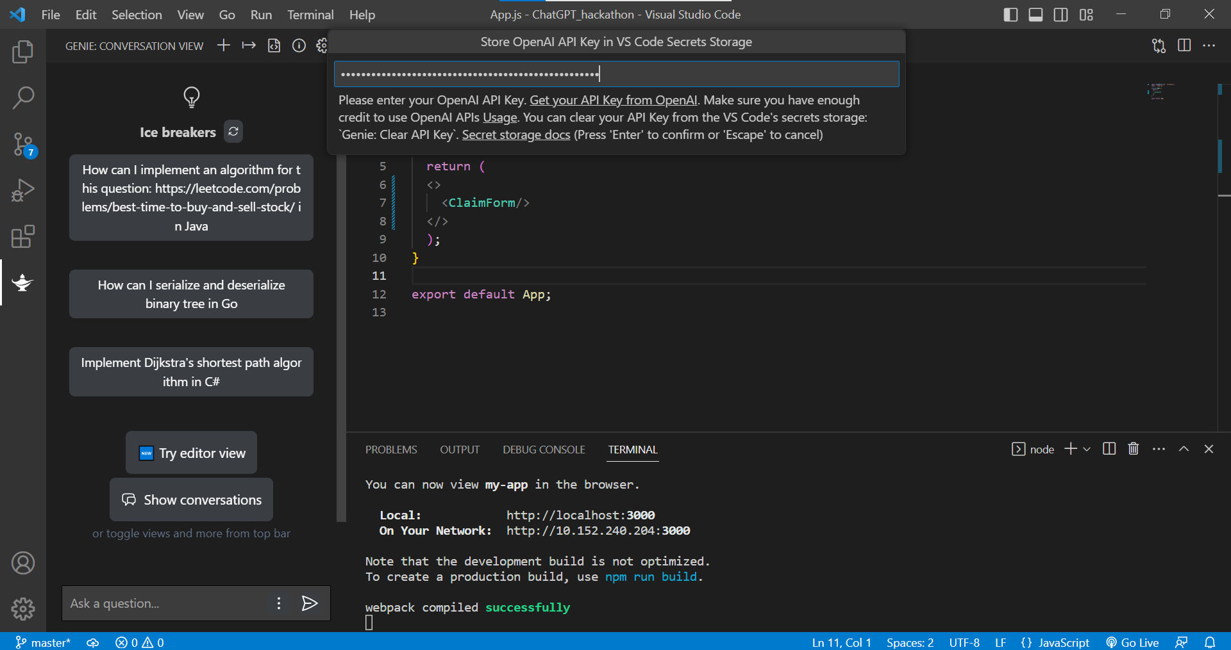

Now, ChatGPT will be responding to the queries given.

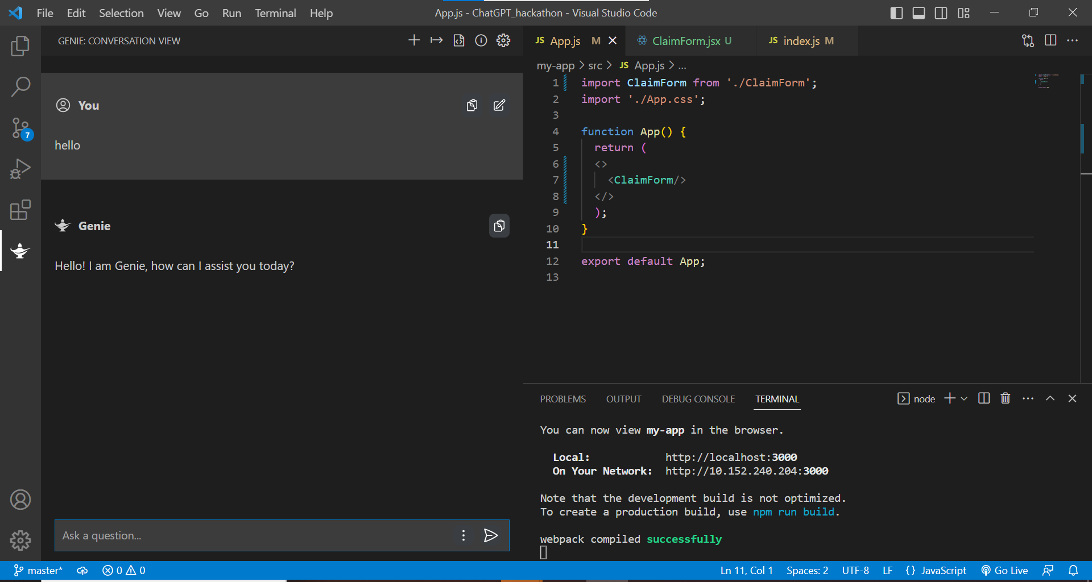

Giving our problem statement to the ChatGpt .

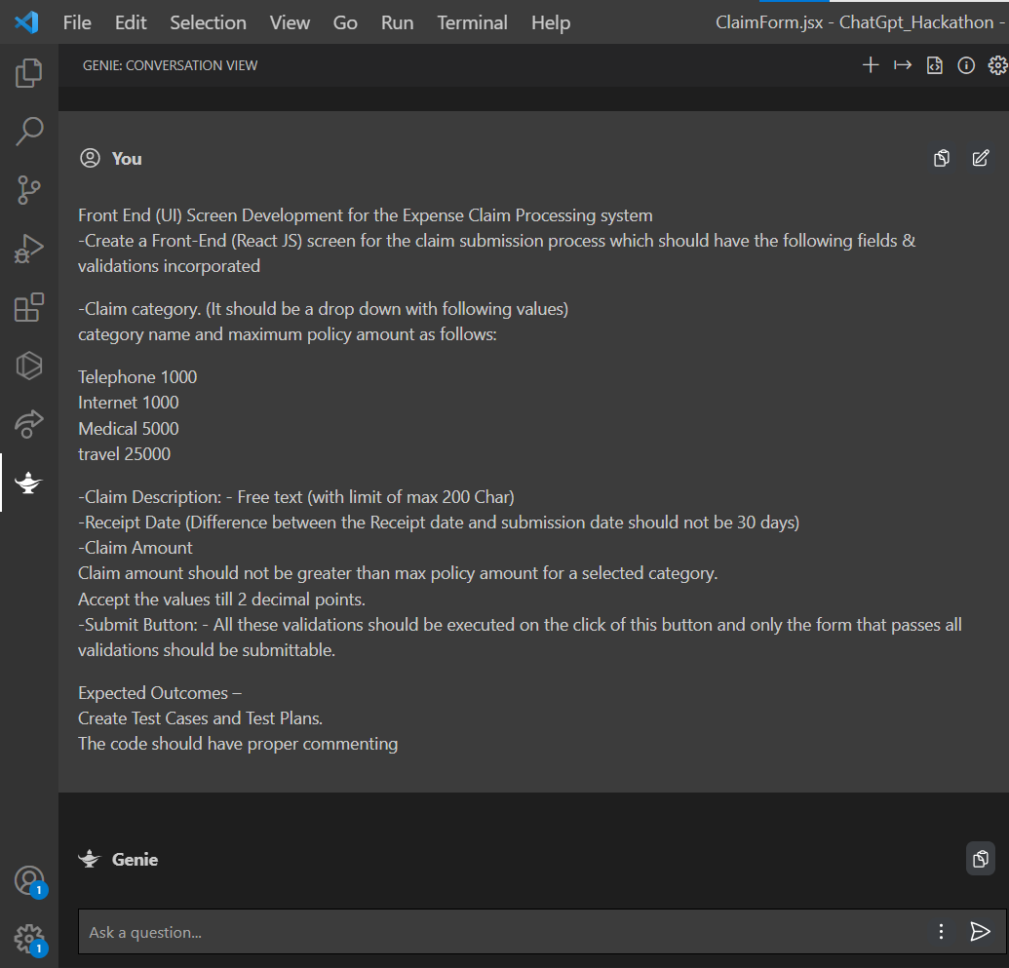

It gives the understanding of the problem statement, what is required to be done.

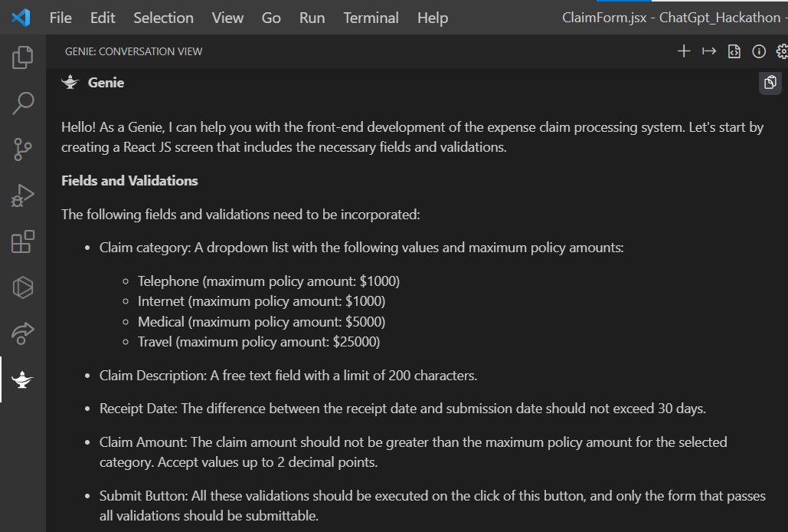

Giving us the detailed explaination of how the test cases and validations should work.

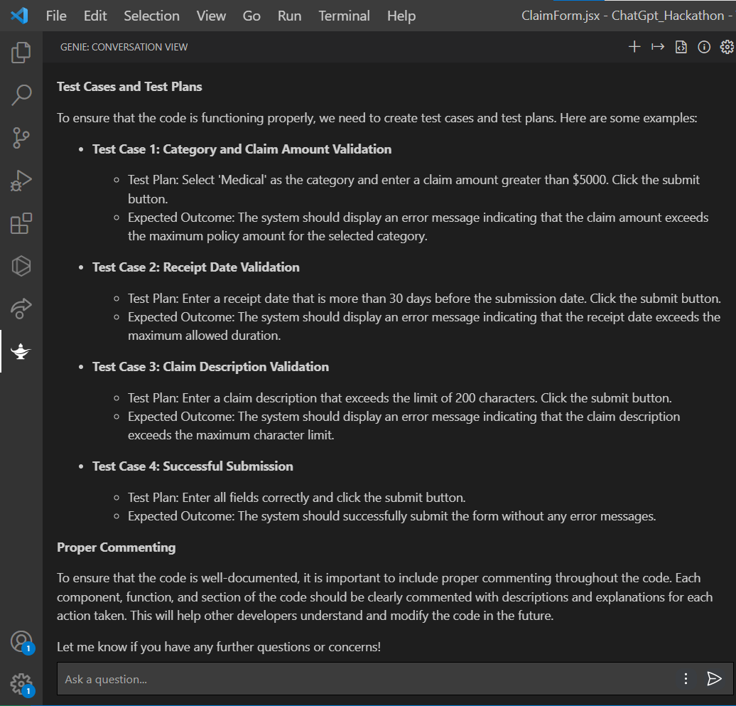

When asked to generate the code for the component, it generates the required code as shown below.

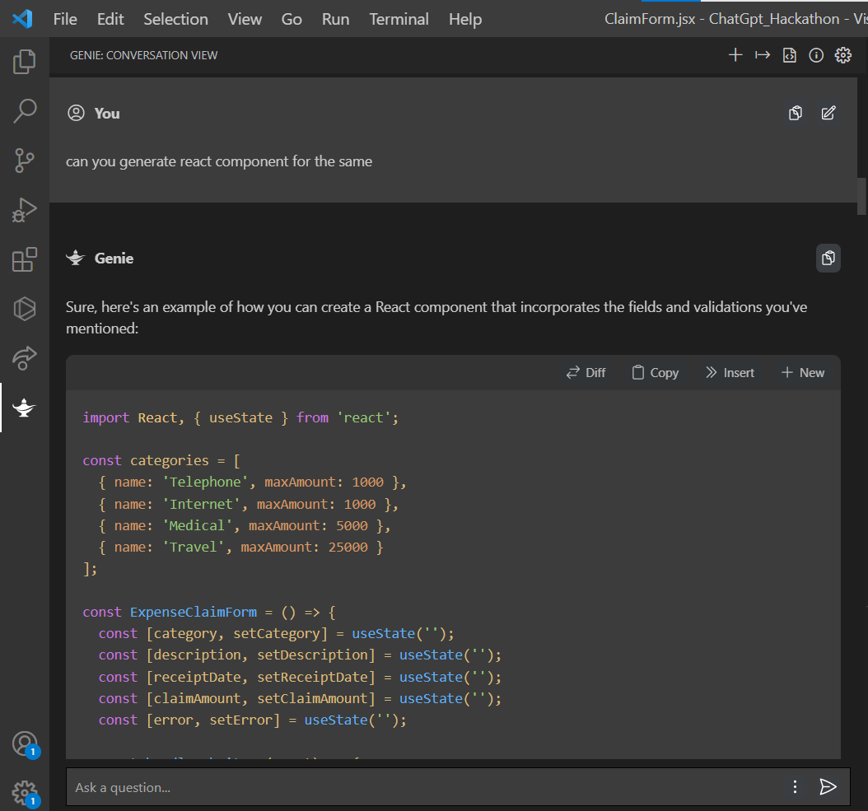

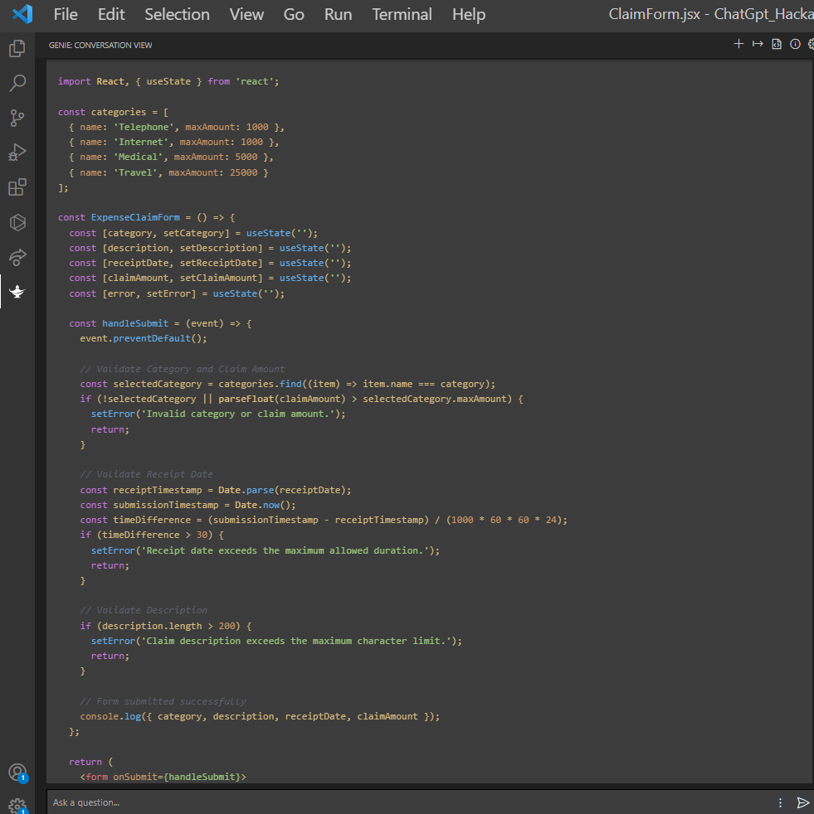

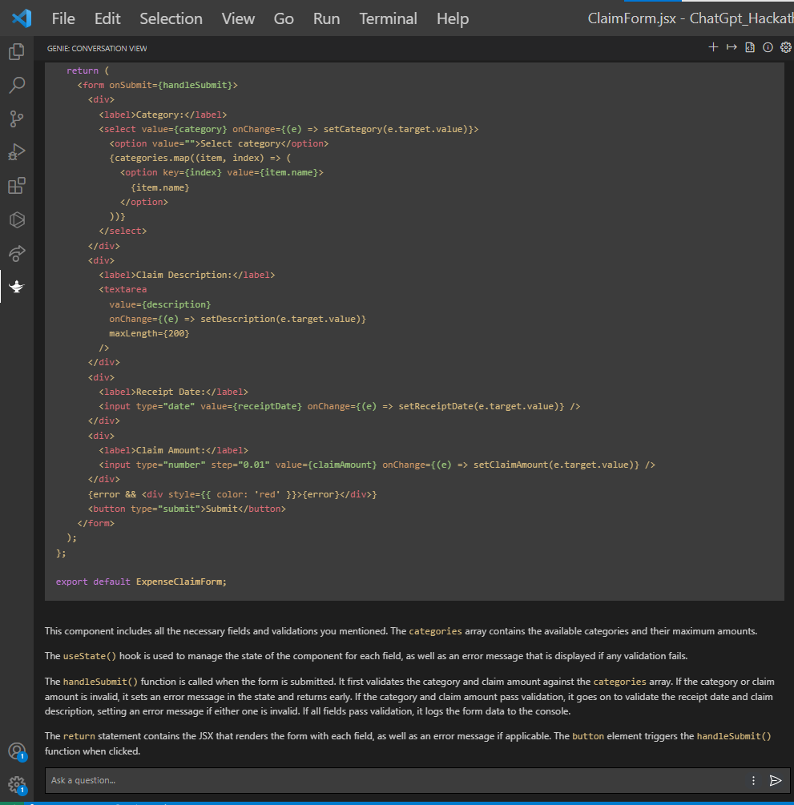

Then, we inserted the code given by ChatGPT in our VS Code, and tried to get the result.

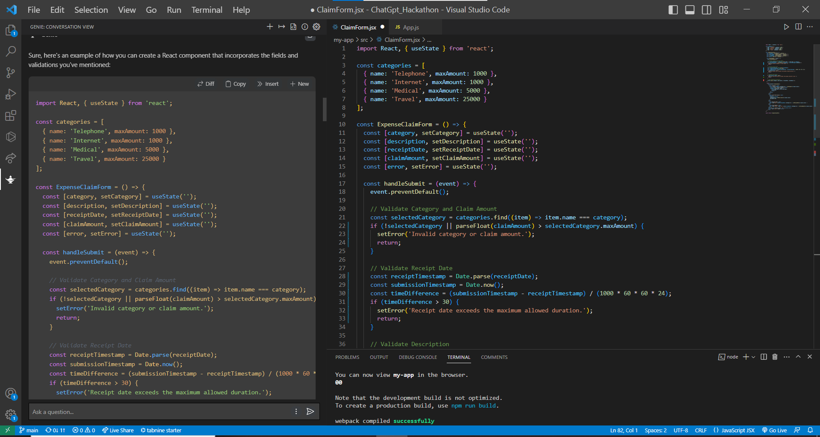

It gives the basic form according to the statement with some checks and validations , but not all. The form created is shown below.

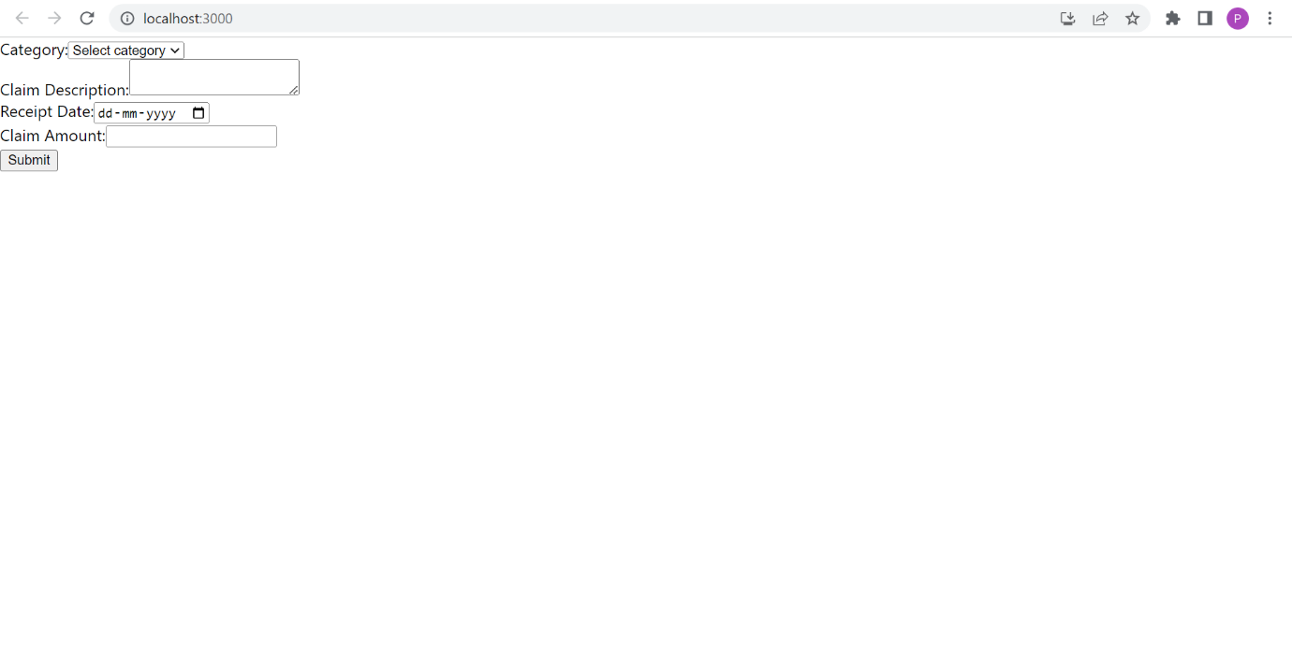

Still some validations were not implemented, so we asked it to check them. After that, it gave result to some extent.

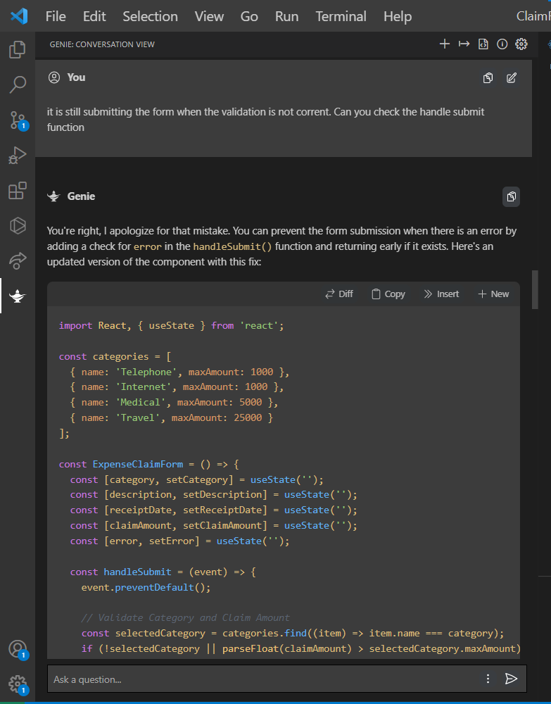

Since all the validations were not correct, so we tried to get the result by different methods. We asked it to use else if for that. Then it gave the right results.

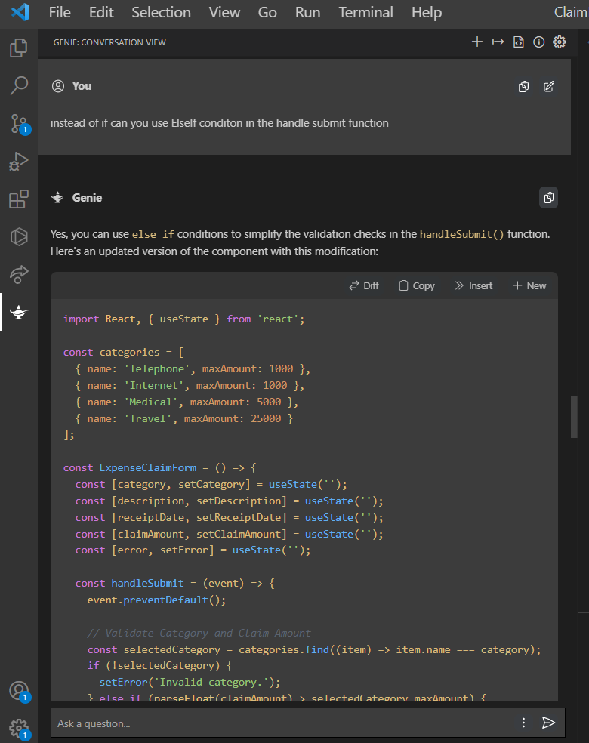

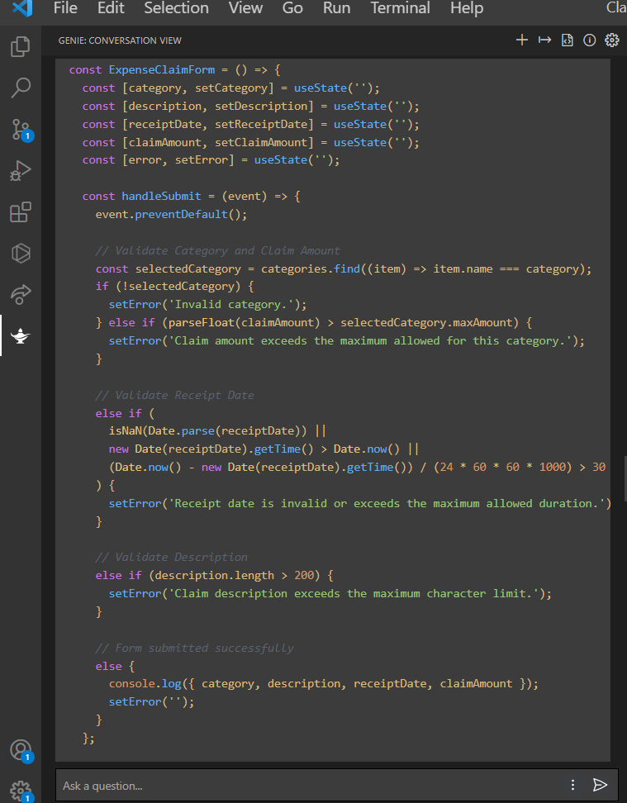

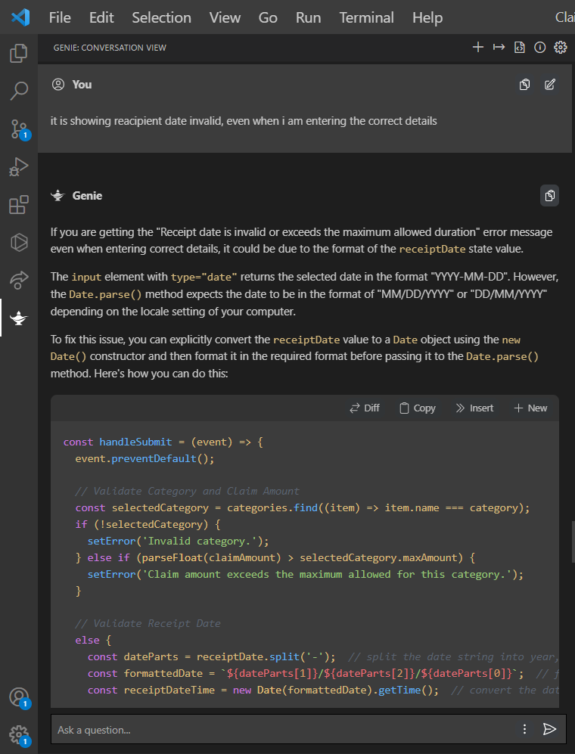

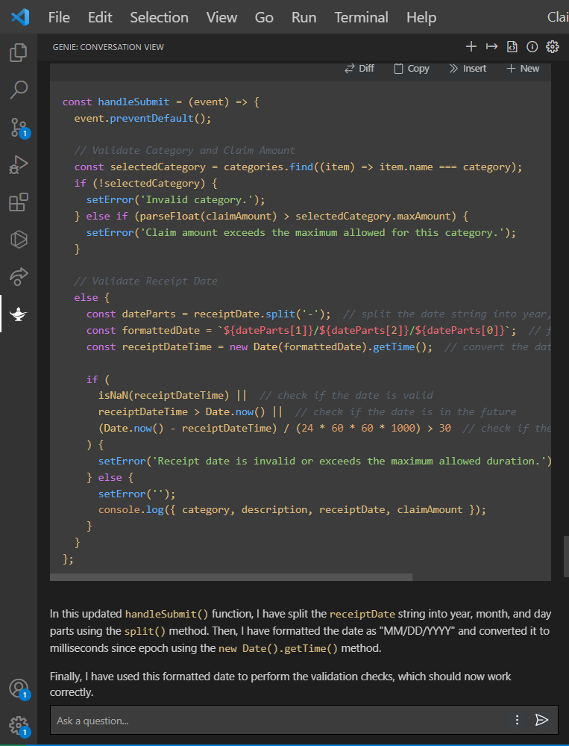

We asked it to apply the specific validations that were not applied.

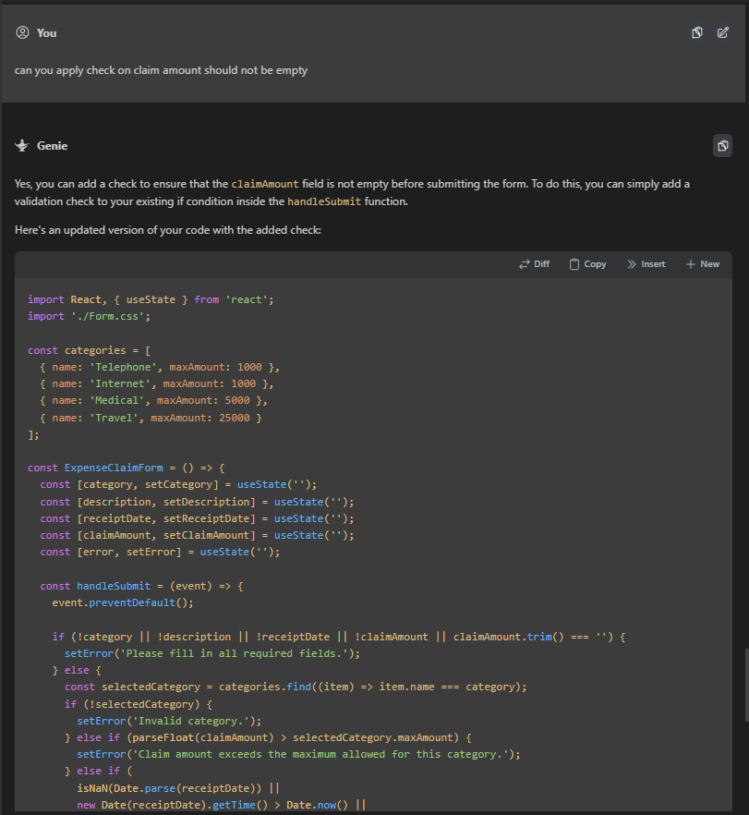

Since the basic form was completed, we asked it to apply some styling in the page using CSS. Here is the code it gave.

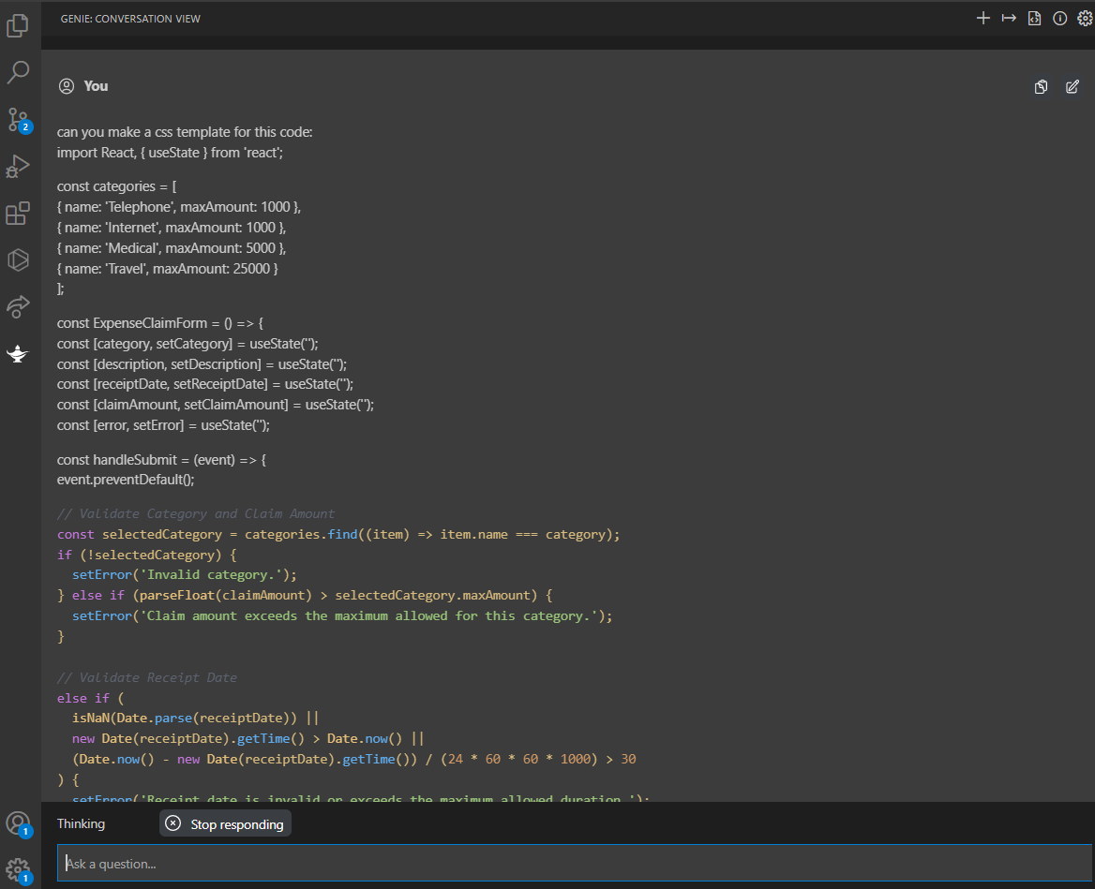

It gave a CSS file along with the classes . It worked quite well.

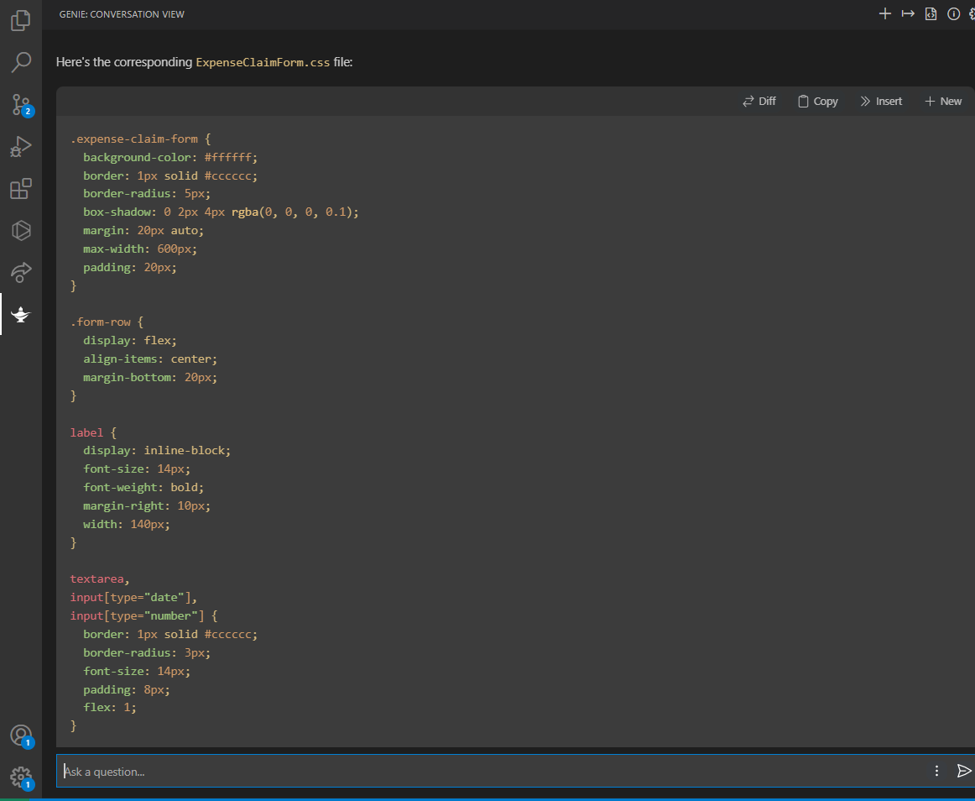

Here is the result we got by applying basic CSS it gave us.

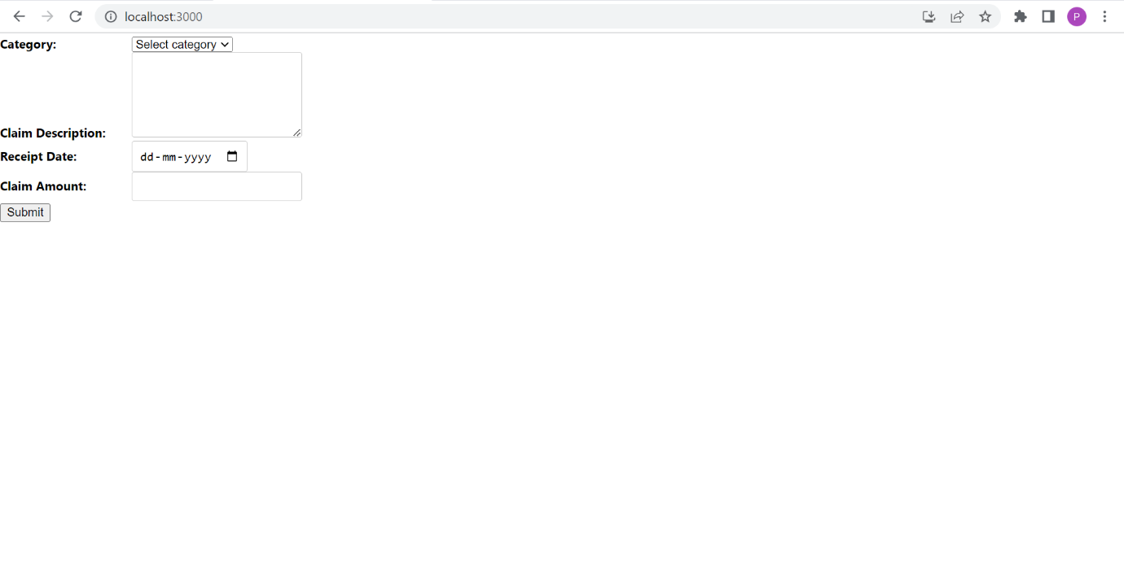

So, to make the page more appealing, we asked it particular tasks like to enclose a form in a box and to align it to the center of the screen.

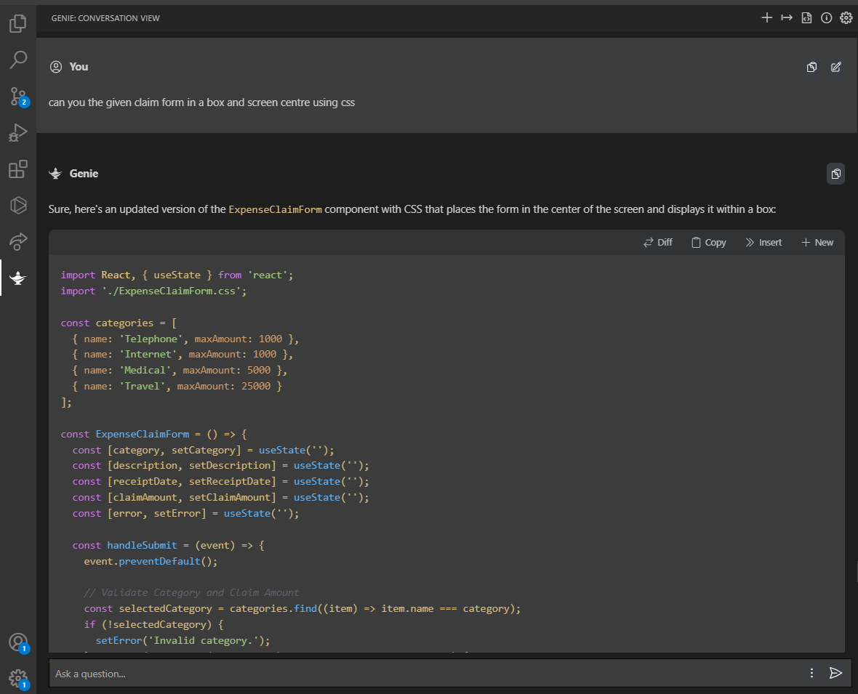

ChatGPT gave the modified code according to the changes we mentioned.

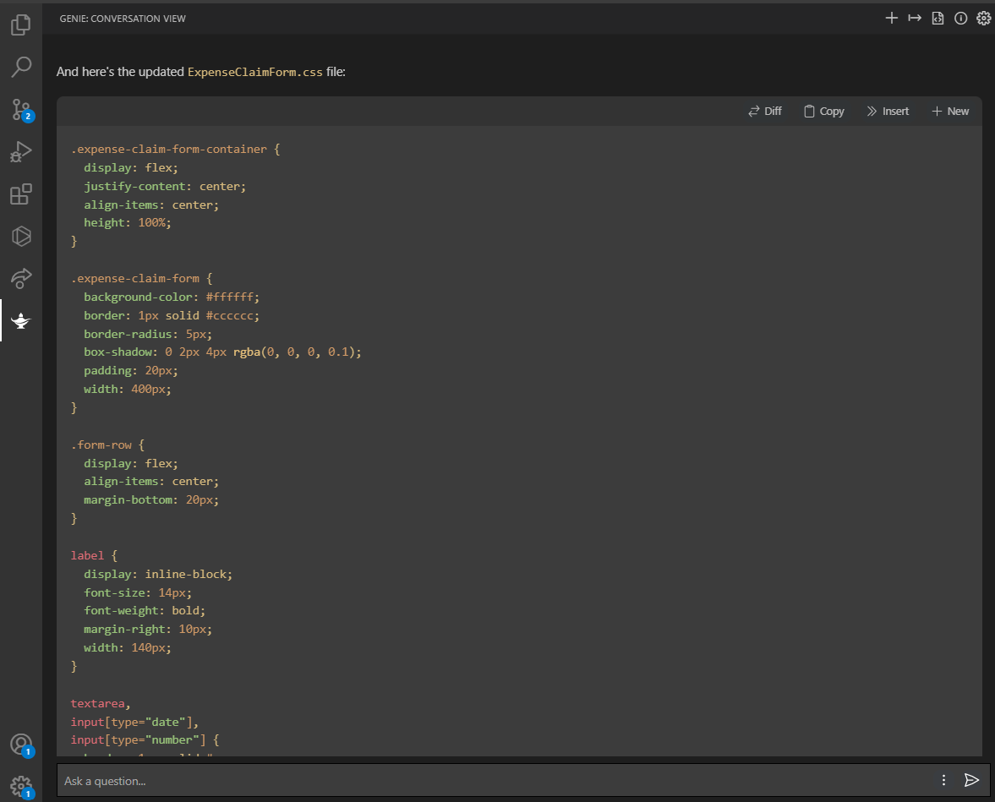

Here the basic design we got after applying basic CSS it gave.

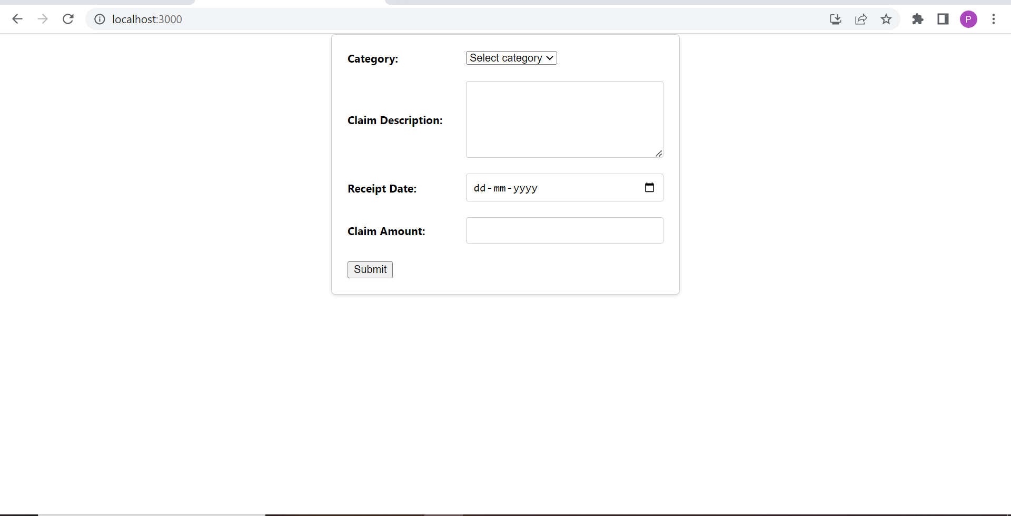

After this, we tried to insert a background image with the help of ChatGpt. It gave the syntax and procedure to do it.

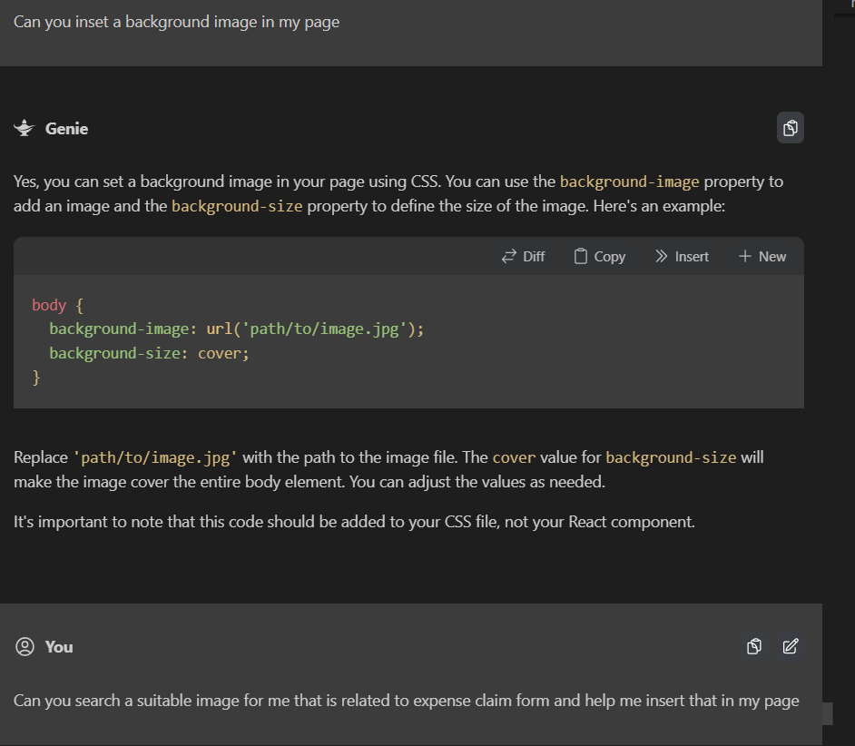

We asked it so search for an related image, it also found an image and also a site for similar images.

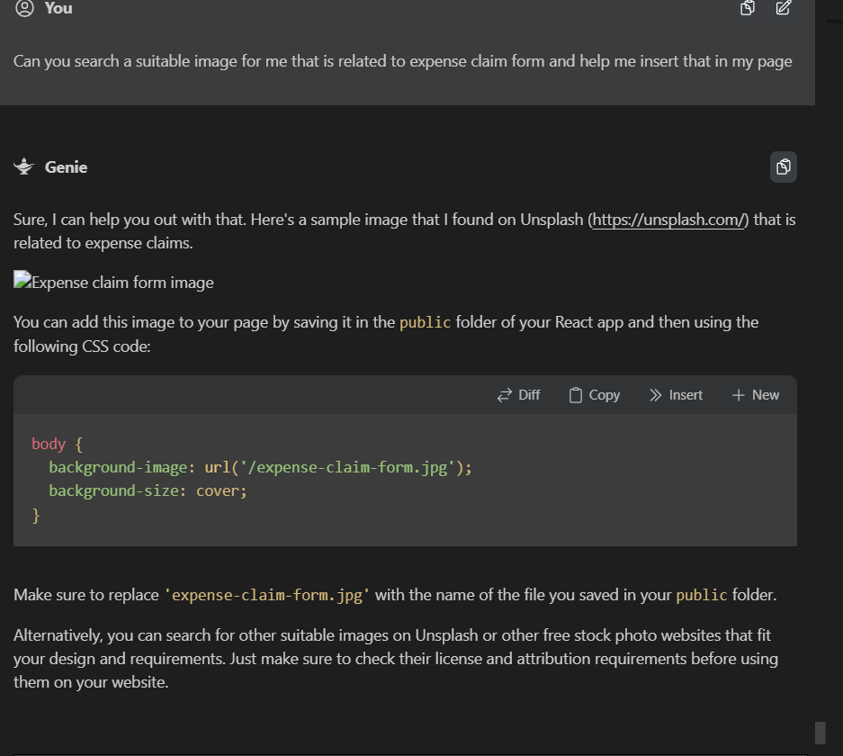

This is how page looks like after image is inserted.

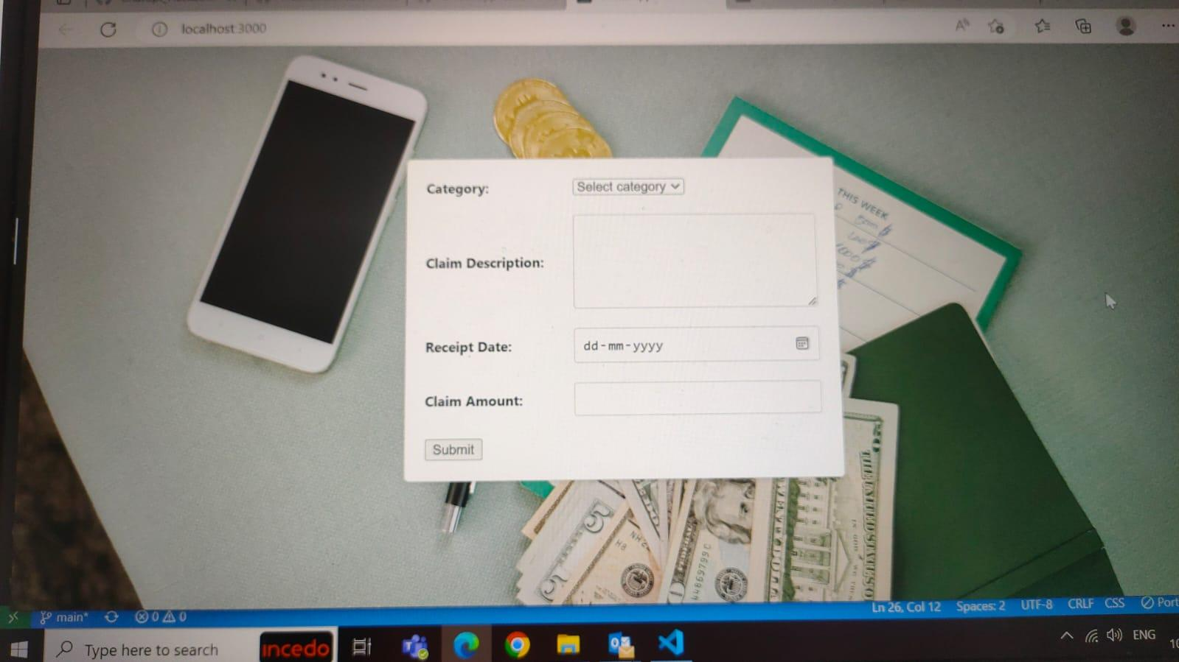

We tried to apply the CSS in the page step by step by specifying the requirements:

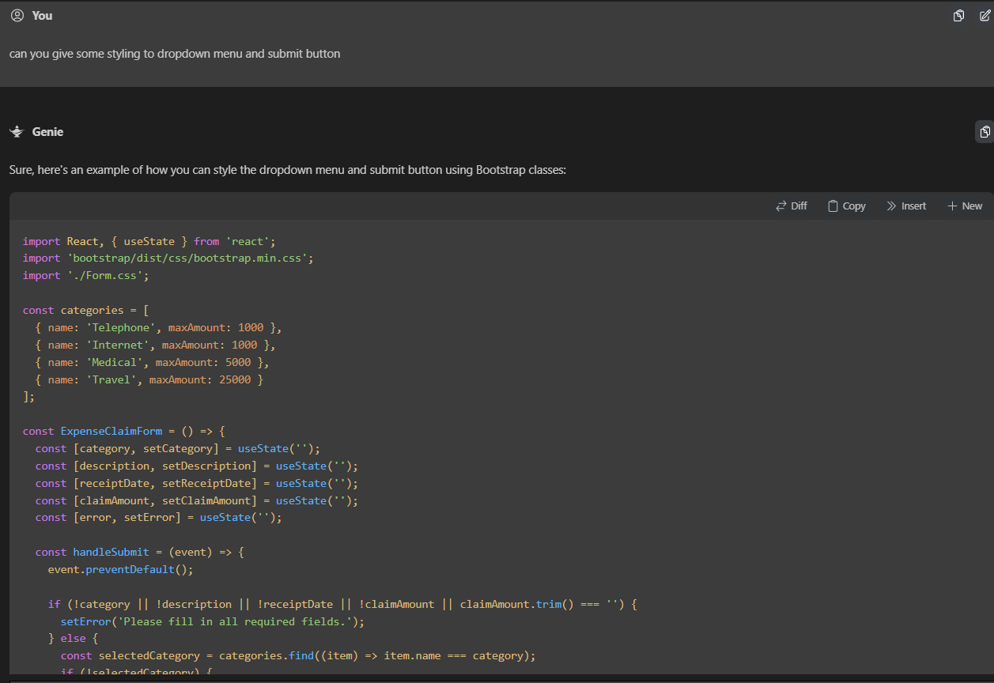



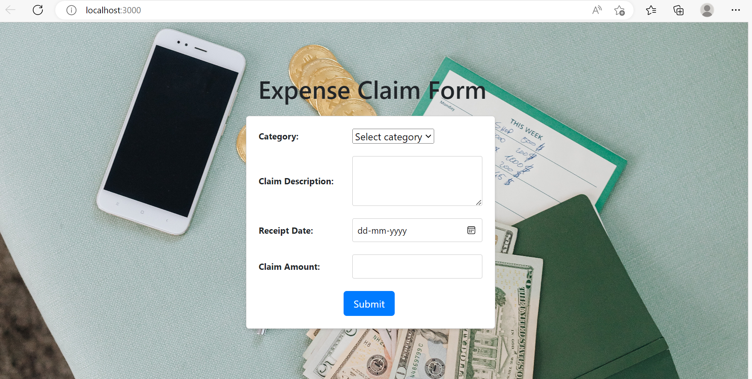

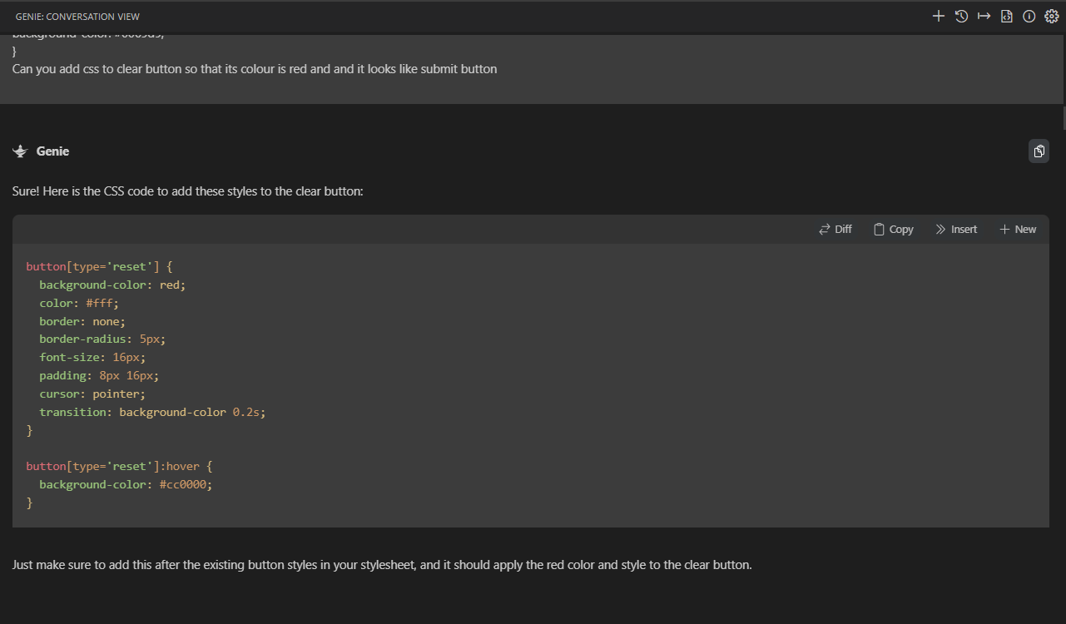

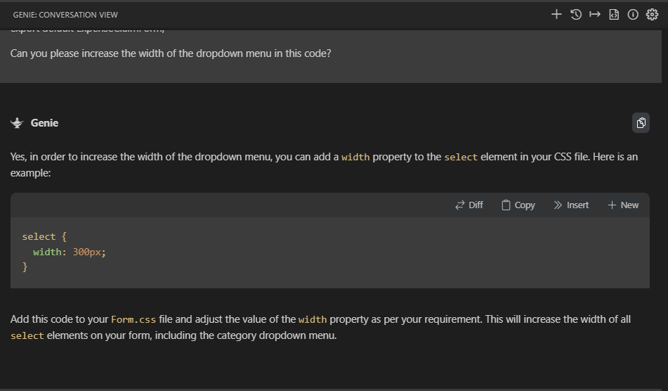

Adding a popup with Chatgpt:

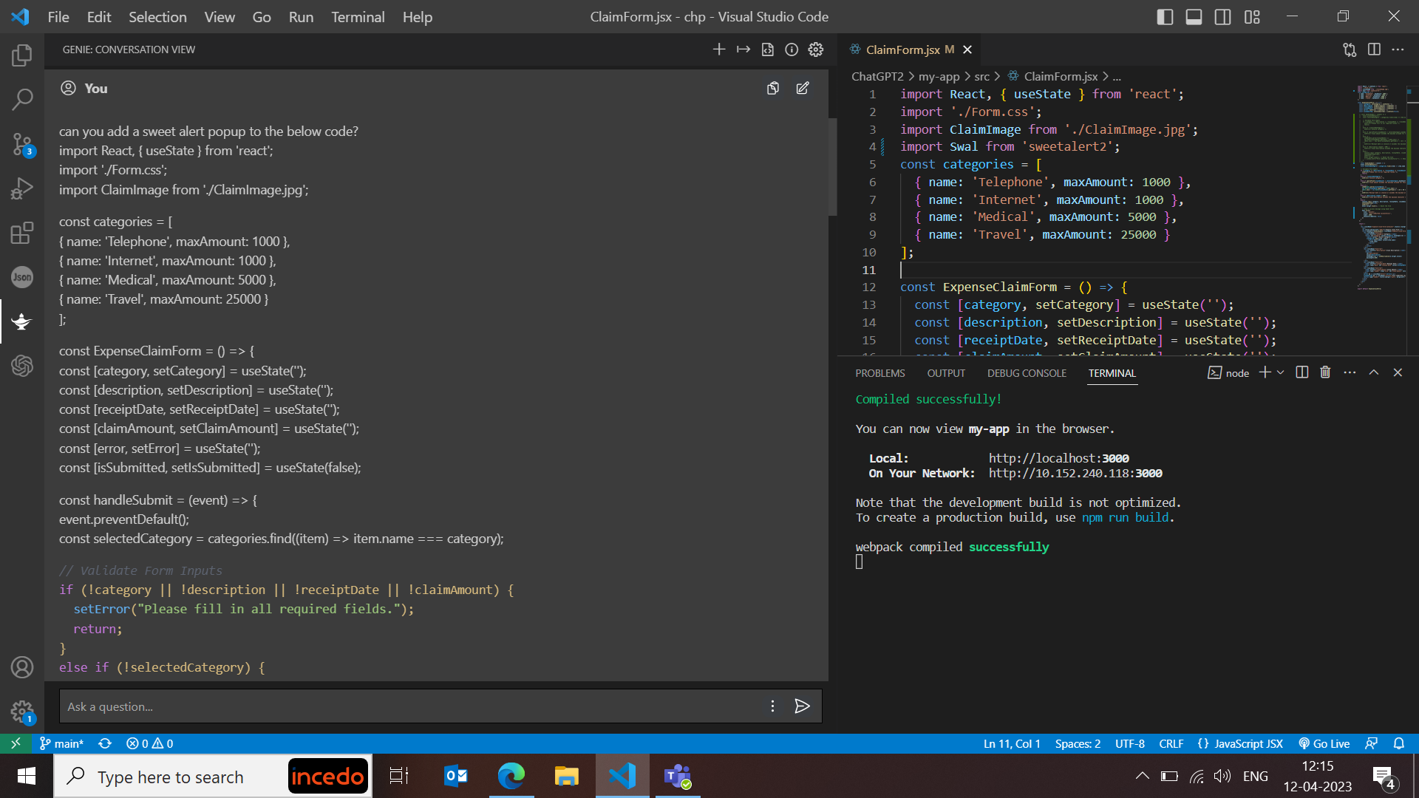

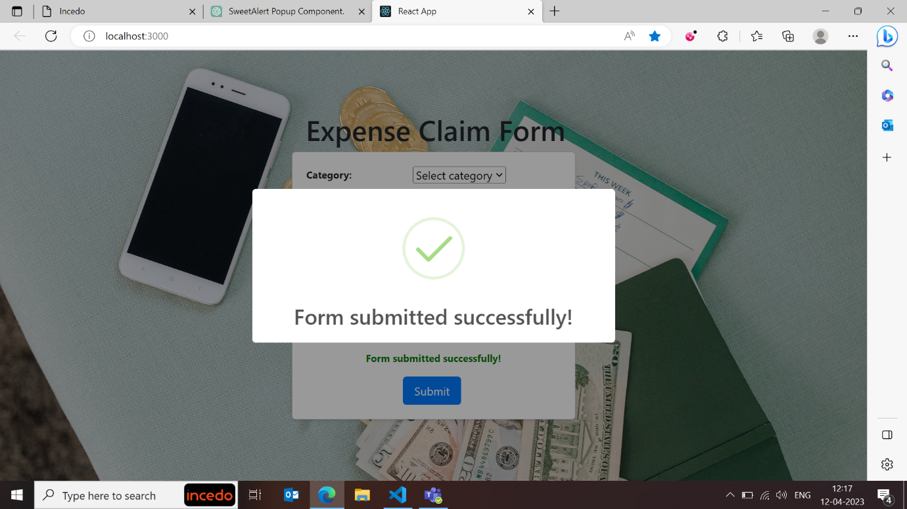

As of now, the page looks like this:

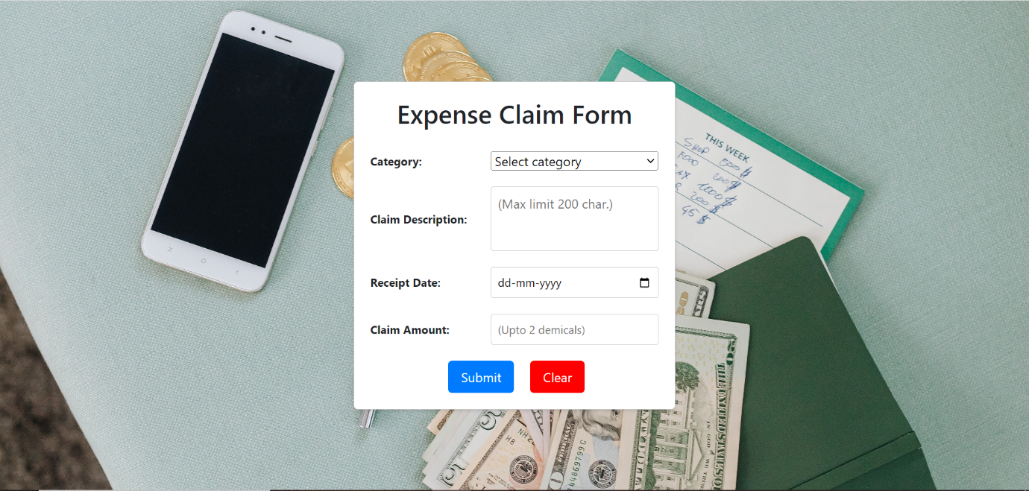

Final screen after suggested changes:

